Assignment 1:

**Objectives:**

1. How to use PL/Sql Developer
2. How to create user in database
3. How to create tables with relations
4. How to write queries and make views
5. How to make web project using C# and Asp.Net
6. Use of basic .net controls like Textbox, labels, grids etcs

You have to design a form on web in using C# and ASP.NET in a single layer architecture and have to perform basic DML operations by writing direct queries from the presentation layer.

**Obtain following information**

CSS file

Linkage tables with data to be imported in the database

**Database Creation:**

Make a database with name of tempwhims using PL/Sql Developer in oracle10g

Import link tables with data into the database

**Data tables:**

1. Make a table named *PH_tmedicine_ master* with following fields

MedicineID Numer (PK) // Auto generated ID

Med_Name Varchar2(200) // To store name of medicine

Med_code Varchar2(25) // Auto, See details below how to make this *

Generic_ Name Number // To store generic name of a medicine, as FK of PH_Tgeneric

Trade_Price Number // To store medicine trade price

Retail _Price Number // To store medicine retail price

**Accouting_Unit** Number // To store unit of medicine, as FK of table PH_tunit

**Nature**  Number // To store nature of medicine, as FK of table PH_tnature

THERAPEUTIC_Group Number // To store information of medicine group, as FK of PH_TTHERAPEUTIC_GROUP

Dosage Varchar2(150) // Use Drop down list containing the dosages

Description Varchar2(250) // Description of medicine if any

Active Cahr (1) // Y for active and N for inactive

**Entered by**  Char(6) // would automatically be filled based upon login, as FK of Hr_tpersonnel

Enteredon Date&Time // It would be system date and time

**ClientID**  Number //005 can be used here

1. Make a table named *PH_tmedicine_suppliers*  with following fields

Med_supplierID Number (PK) // Auto generated ID

MedicineID Number (FK) // To store medicine ID. Linked with PH_Tmed_master

SupplierID Number (FK) // To store medicine ID. Linked with HR_Tp_supplier

**Medicine Code:**

*Medicine Code (Med-Code) will be made based upon the following consideration it would include

First three characters of medicine generic name

Next three characters of medicine name

Next four characters of THERAPEUTIC group

Next three characters of dosage

Next three characters of nature

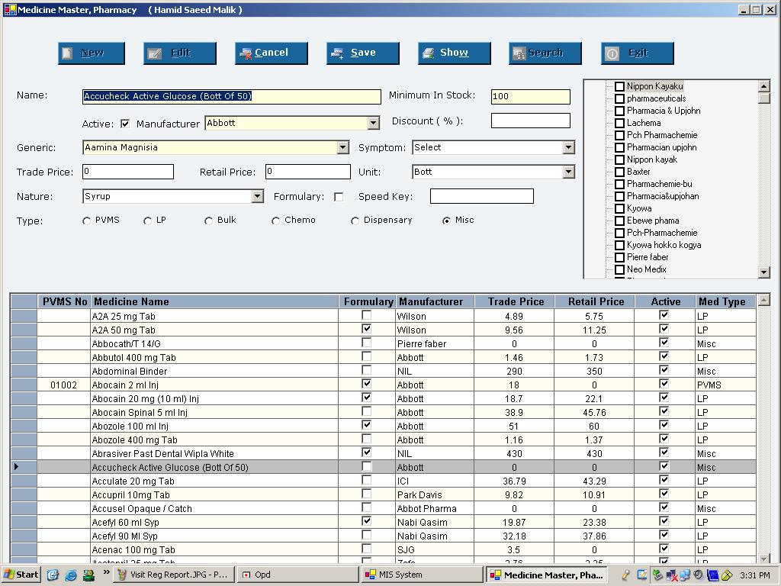

**Following operations are to be carried out in this web page:**

1. It should be following login based user authentications
2. Use the given CSS in the project
3. Code to be commented properly
4. Addition of new medicine
5. Update of existing medicine
6. All mandatory fields labels right side should be marked red
7. Search facility within the same page
8. Tool tips for all the fields which should be easy to understand, water marking using AJAX (Optional)